**[Complex artificial intelligence models for energy sustainability in educational buildings](https://pmc.ncbi.nlm.nih.gov/articles/PMC11217432/?)**

**Author:**  Rasikh Tariq ,Awsan Mohammed ,Adel Alshibani ,Maria Soledad Ramírez-Montoya

**Publication:** *Scientific Reports*, Volume 14, Article number 15020, on July 1, 2024.

**Model diagram:**

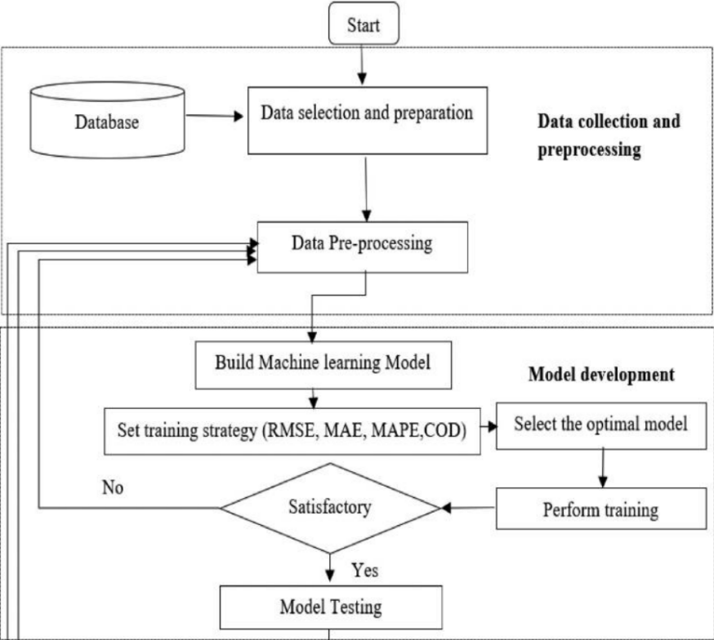

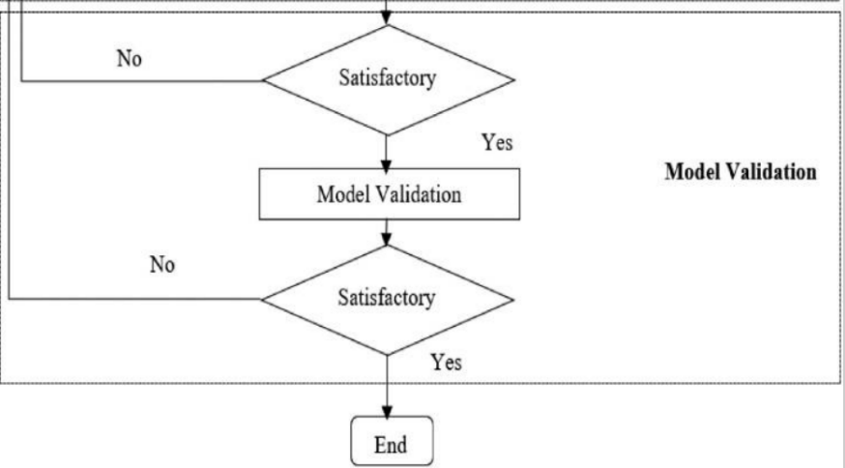

**AI Models and Techniques Used**

* **Algorithms Applied:**
  + Decision Trees (DT)
  + K-Nearest Neighbors (KNN)
  + Gradient Boosting (GB)
  + Long Short-Term Memory (LSTM) Neural Networks
* **Best Performing Models:**
  + **Gradient Boosting:** This model performed exceptionally well, providing almost perfect predictions on training data (RMSE: 374.79, Coefficient of Determination (COD): 0.999993).
  + **LSTM:** This model was great for understanding the time-related factors that affect energy consumption, giving it strong generalization with a COD of 0.9756 on the testing data.
  + **Decision Tree:** While this model wasn’t the best at predicting accuracy, it was easy to understand and interpret, with a Mean Absolute Percentage Error (MAPE) of around 3.58%.

**Key Findings**

* **Critical Factors for Energy Consumption:**
  + **Strong Correlations:** The biggest factors influencing energy use were the school’s **size** (total built area, roof area) and **air-conditioning capacity** (with a very strong correlation of 0.97).
  + **Weak Correlations:** Things like the **type of school** and **building age** had much less impact on energy consumption.
* **Performance of Models:**
  + **Gradient Boosting** outperformed all other models, while **KNN** showed signs of overfitting (with a very high RMSE of 38,429 on training data).
  + The energy consumption in the study ranged from **99,274.95 kWh/year** to **683,191.8 kWh/year**.

**Dataset Details**

* **Source:** The data came from **352 educational buildings** in hot climates (likely in Saudi Arabia, given the authors' affiliations).
* **Variables Included:**
  + **Inputs:** City, number of floors, total built area, roof area, school type, number of students and staff, building age, number of classrooms, air-conditioned area, and AC capacity.
  + **Output:** The annual **energy consumption** (measured in kWh/year).
* **Data Preprocessing:**
  + The data was **normalized** using a technique called MinMaxScaler for LSTM models.
  + **Outlier removal** was done, and correlation analysis was performed to remove less impactful variables like **lamp types**.
* **Dataset Availability:** The dataset is available upon request from the authors (**Prof. Rasikh Tariq** and **Prof. Awsan Mohammed**).  
  **Geographic Bias:** The dataset mainly focuses on **hot climates**, which means the AI models might need adjustments to work in cooler climates.
* **Integration with Smart Systems:** Future work could involve connecting AI predictions with **smart IoT systems**, so energy consumption can be controlled in real-time based on AI recommendations.
* **Educational Applications:** AI tools could also be used to **engage students** in sustainability efforts, such as using real-time dashboards that show energy usage.

**Relevance to Sustainable Campuses**

* **AI-Driven Insights:**
  + The AI models can help campuses **predict and manage energy consumption** better, like optimizing HVAC schedules or retrofitting buildings to be more energy-efficient.
  + Real-time energy data could also be used to turn campuses into **interactive learning hubs**, teaching students about sustainability.
* **Scalability:** The variables considered in the study—like **occupancy** (students and staff) and **AC capacity**—apply to most campuses, making the models scalable across different universities or schools.

**Limitations and Future Directions**

* Geographic Bias: The dataset mainly focuses on hot climates, which means the AI models might need adjustments to work in cooler climates.
* Integration with Smart Systems: Future work could involve connecting AI predictions with smart IoT systems, so energy consumption can be controlled in real-time based on AI recommendations.
* Educational Applications: AI tools could also be used to engage students in sustainability efforts, such as using real-time dashboards that show energy usage.